|  |
| --- |
| NCTS Trader Portal Guide  UCC - NCTS  EUROPEAN DYNAMICS  **November 2023** |

**Document History**

|  |  |  |  |
| --- | --- | --- | --- |
| **Version / Date** | **Author** | **Description** | **Action** |
| v0.1 31/11/2023 | ED | First Version. | C |
|  |  |  |  |
|  |  |  |  |
|  |  |  |  |
|  |  |  |  |

# Table of Contents

Table of Contents 3

Table of Figures 5

Table of Tables 6

1 Introduction 7

1.1 Purpose 7

1.2 Document Structure 7

2 General UI elements and basic tasks 8

2.1 Logging-in 8

2.2 Main application screen 8

2.2.1 Common Screen Elements 8

2.2.2 Field indicators 10

2.3 Common Components 11

2.3.1 Grid Column Headings 11

2.3.2 Grid Footer 11

2.3.3 Advanced Filter 12

2.3.4 Form Tab 14

2.3.5 Short Search lists 15

2.3.6 Long Search lists 16

2.3.7 Date Selector 17

2.3.8 Document attachments 17

2.4 Interface Scaling (Adaptive Behaviour) 18

2.4.1 Full size display example: 18

2.4.2 Next smaller screen size: 18

2.4.3 Smallest screen size display: 19

3 Basic Concepts and Terms 21

3.1 Declaration 21

3.2 Declaration Status 21

4 Main interface sections 22

4.1 Overview: 22

4.1.1 Declarations: 22

4.2 Transit Declaration 25

4.2.1 Draft declarations 25

4.2.2 Required vs. Validated data elements 26

4.2.3 Validation errors 27

5 Creating and Submitting Declarations 29

6 Declaration Specific Guidance Information 30

6.1 Creating a specific declaration / notification 30

6.2 Declaration Amendment (Holder of the Transit Procedure initiated) 30

6.3 Declaration Amendment (Customs Officer Amendment request) 31

6.4 Declaration Invalidation (Holder of the Transit Procedure initiated) 31

6.5 Declaration Invalidation (Customs Officer Invalidation request) 31

6.6 Attaching a Document to a Declaration 32

7 Appendix Α – Declaration Action Matrix 34

# Table of Figures

Figure 1 NCTS Login Screen 8

Figure 2 Common Screen Elements 9

Figure 3 Grid column headings 11

Figure 4 Grid footer 11

Figure 5 Advanced filter component 12

Figure 6 Form tab 14

Figure 7 Short search list 15

Figure 8 Long search list 16

Figure 9 Date selector 17

Figure 10 Document attachments 17

Figure 11 Full Size Screen example 18

Figure 12 Intermediate Screen Size example 18

Figure 13 Select Section example 19

Figure 14 Smallest screen example 19

Figure 15 Smallest screen size show menu 20

Figure 16 Declaration Overview grid example 22

Figure 17 Customs Declaration detail header 23

Figure 18 Movement messages grid 23

Figure 19 View Declaration Message screen example 24

Figure 20 Supporting Document (Attachment) grid 25

Figure 21 Draft declarations grid 26

Figure 22 Required fields missing 26

Figure 23 Validation errors screen example 27

Figure 24 Uploading an Attachment 32

Figure 25 File Browser example 32

# Table of Tables

Table 1 Declaration Overview grid columns 22

Table 2 Invalid Attachment File Types 32

Table 3 Common Supported Attachment File Types 33

Table 4 Movement state Action Matrix 35

# Introduction

## Purpose

The purpose of this document is to describe the Trader NCTS Functions. It describes the user interface through which Traders will be exchanging information with Customs Authorities to conclude end-to-end business processes for the automation of the common and union transit procedures as well as control of the movements covered under the TIR procedure within the EU.

This guide is not intended for and does not describe the B2B (Business to Business) communication between Traders, their agents or representatives and Customs Authorities. However, any messages submitted via the B2B interface will be visible οn the Trader Portal.

This document is not the Trader NCTS Technical Specification and as such it does not contain any technical related information e.g. authorisation, authentication, end points etc.

## Document Structure

This document is divided into the following sections:

1. General UI elements and basic tasks
2. Basic Concepts and Terms
3. Main Interface Sections
4. Creating and Submitting Declarations
5. Declaration Specific Guidance Information
6. Appendix Α – Declaration Action Matrix

# General UI elements and basic tasks

## Logging-in

To access the Trader Portal, navigate to the homepage of the Trader portal and fill the username and corresponding password:

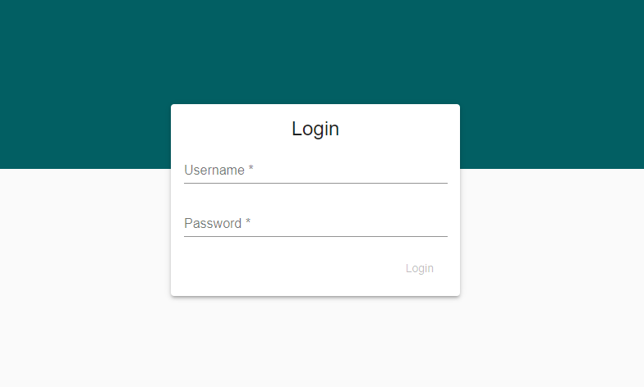

Figure 1 NCTS Login Screen

## Main application screen

### Common Screen Elements

The interface consists of the following screen elements as shown in the screenshot below:

1. Menu show/hide button (shows / hides the section selector)
2. Menu section (collapsible sections)
3. Action Selector (list of available actions depending on selected object)
4. Message Alert indicator / Screen Inactivity timer / Logout button.
5. Grid/Page Navigation Buttons
6. Home Button
7. Back Button
8. Header Area (where applicable)
9. Detail Grid Area (Where applicable)
10. Attachments Grid (Where applicable)

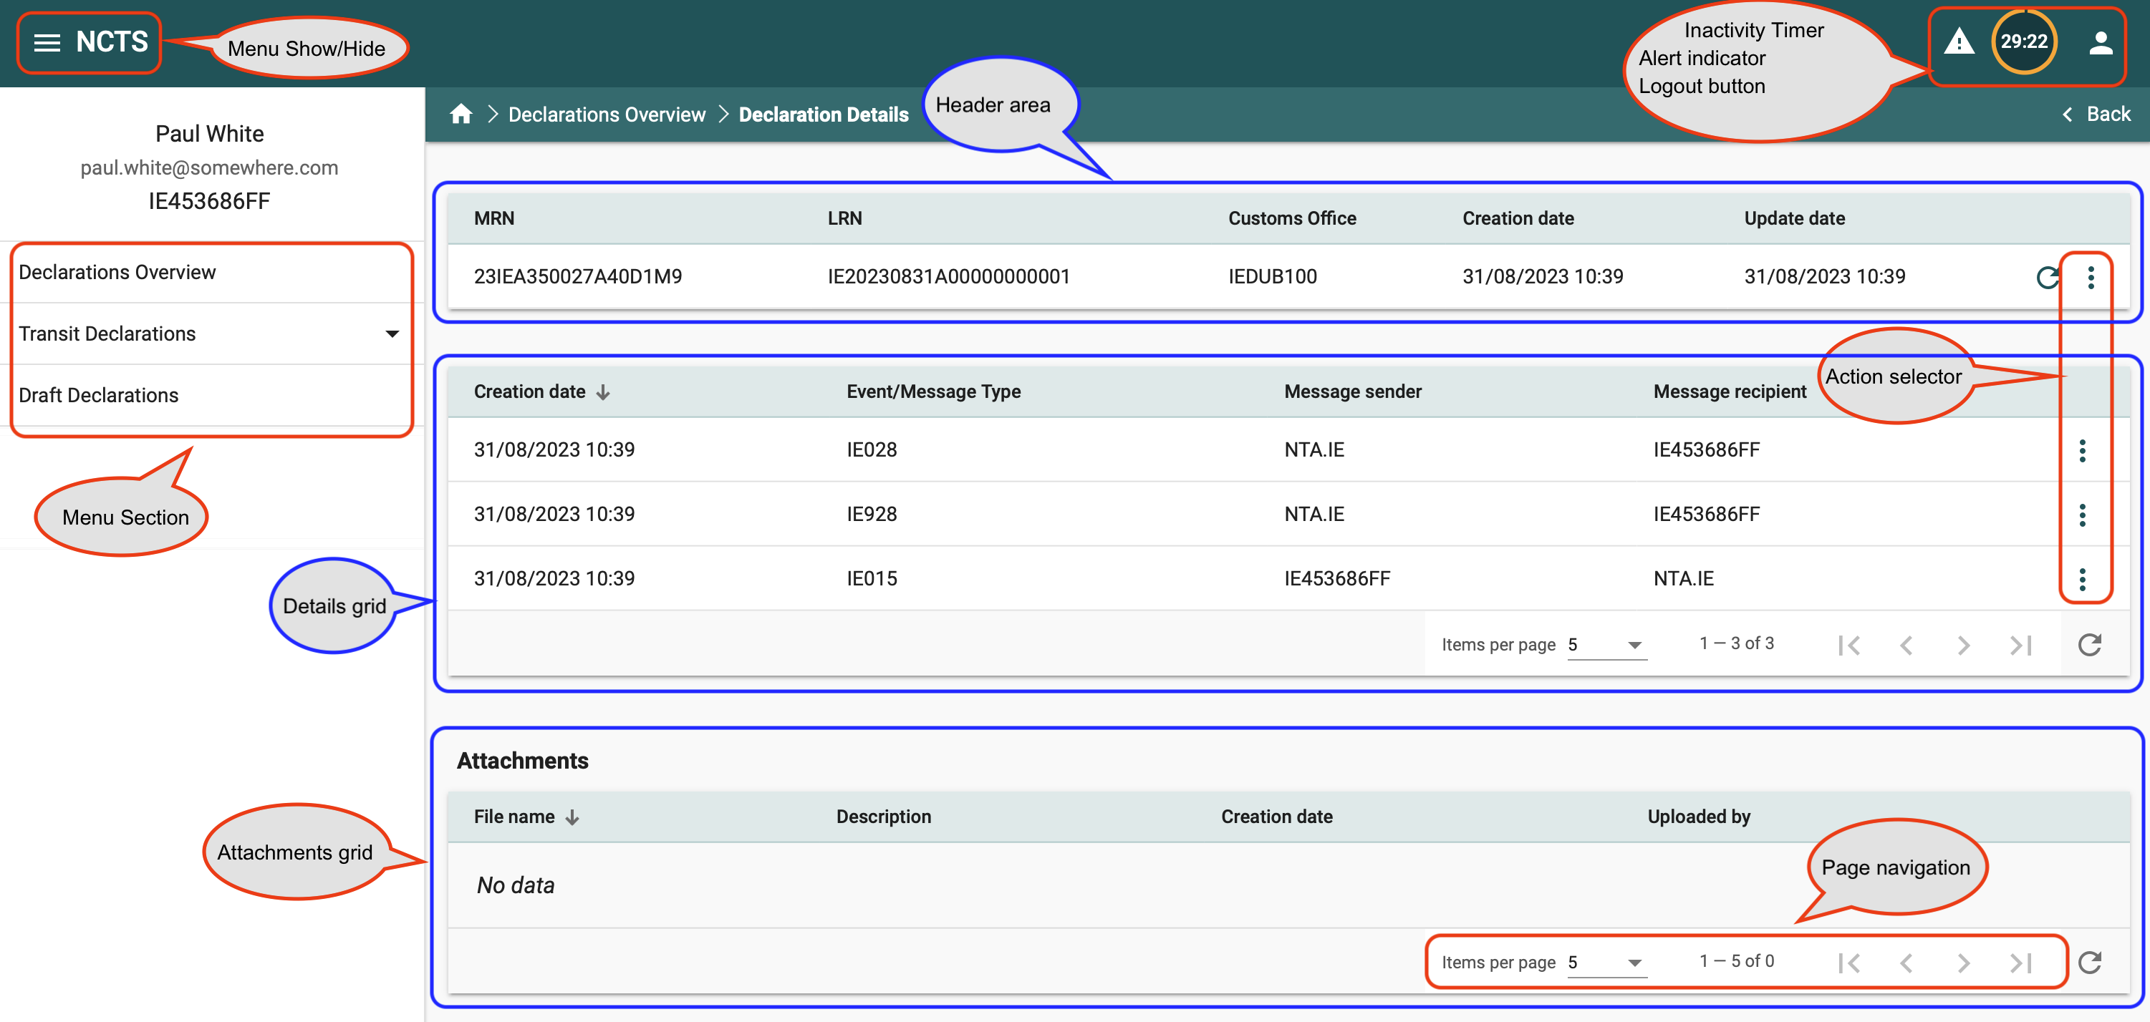

Figure 2 Common Screen Elements

### Field indicators

This section describes the special indicators that might be used in fields where data entry is expected.

1. Mandatory fields. A field that is marked with an asterisk icon, as in the image below, is mandatory. All mandatory fields of a form must be completed before the form can be submitted.



1. Long search lists. A field that is marked with a magnifying lens icon, as in the image below, is data restricted by the search list component.



1. Short search lists. A field that is marked as in the image below is data restricted by the short drop-down component.
2. Date selector. A field that is marked with a calendar icon, as in the image below, is complemented with the date selector component.

## Common Components

The following sections describe common components that are used as part of the application grids and forms.

### Grid Column Headings

Column headings are displayed as in the following example:



Sort Direction

Figure 3 Grid column headings

By clicking on any of the column headings, an ascending sort is performed on the data of the selected column. The “Sort Direction” indicator is shown with an arrow as marked in the image above. The direction of the arrow denotes the direction of the sort order (ascending / descending). The sort order is numeric, alphabetic or by date depending on the type of data in the selected column.

Ascending sort order is applied by default when selecting a column. To change the sort direction, simply click on the arrow next to the column name.

### Grid Footer

The footer element of a data grid is displayed as in the following example:



Figure 4 Grid footer

Each footer consists of three sections:

1. 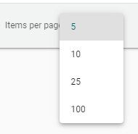Items per page:
   1. This section displays the number of items displayed (default is 5)
   2. Clicking on the arrow next to the number of items indicator, reveals a drop-down list with the option to display 10, 25, or 100 items per page as shown on the right.
   3. The range of items displayed and the total number of items in the grid is displayed next to the “Items per page” part of the footer. (e.g. 1 – 5 of 27)
2. Page navigation controls

The page navigation controls contain four action arrows as shown below



Go to First Page

Previous Page

Next Page

Go to Last Page

1. Refresh Icon

The refresh icon simply refreshes (reloads) the displayed grid data.

### Advanced Filter

The advanced search component, where available, provides the following functionality:

1. Selection of multiple filters, combined with AND/OR logic
2. Provides sorting criteria
3. Allows saving a “search” (collection of filters and sorting method created by the user) for easy recall and use.

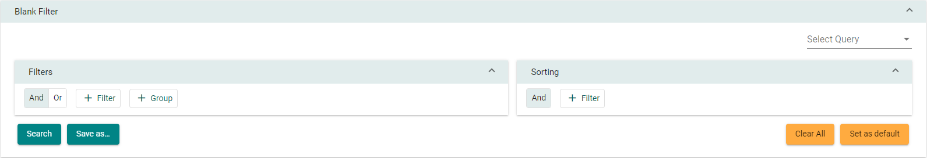The initial advanced search facility screen is shown below:

Figure 5 Advanced filter component

The Search facility consists of two main sections (Filters and Sorting), a “Select Query” drop-down element which allows the selection of a previously saved search, and four buttons:



This button ‘runs’ the search, causing the grid below the search section to display any matching data.



This button opens the “Save Criteria” dialog box (please see next section)



This button will “clear” any entered information in the search facility, essentially resetting the search facility to its initial state.



This button will reset the grid view to its initial sorting state with no filters applied.

#### Adding a search criterion (Rule)

1. 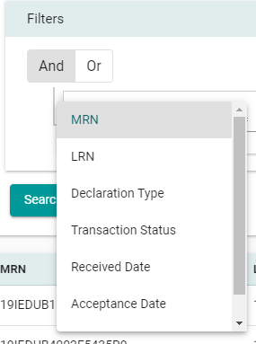Click on the button.
2. Select the search field name from the drop-down list as shown on the right. (The drop-down list in the example is from the “Declarations” section).
3. Multiple filters can be selected in this manner.
4. Additionally, an ‘AND’ / ‘OR’ logic can be selected that will apply to all the configured rules.
5. Rules can be removed by clicking on the icon.
6. A collection of rules created this way is a “Rule Set”.
7. Multiple “Rule Sets” can be defined by clicking on   
   the button.
8. Each “Rule Set” has its own logic component (AND/OR)

#### Configuring the search “Sort Order”:

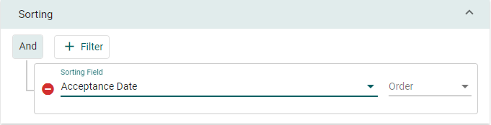The sort component of the Search facility is shown in the following picture:

1. The same principles apply here as in the Search (filter) section.
2. Any number of consecutive sort criteria can be defined, always with an ‘AND’ logic.
3. Each sort criterion is accompanied by a ‘Descending / Ascending’ selector.

#### Saving configured search criteria

The configured search, complete with the sorting options selected, can be saved for future use requiring only a unique name. Searches can be saved by clicking on the button.

The “Save as” dialog box is shown on the right.

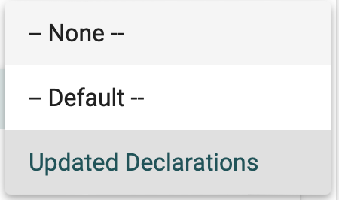The saved search criteria name will be available from a drop-down list in the “Select Query” (as shown on the right).



The saved search can be deleted by clicking on the button, which appears when selecting a saved search.

### Form Tab

The component allows the user to add, remove and navigate tabs. Each tab represents a record that can be repeated in the enclosing section of a form.

Figure 6 Form tab

The component includes the following parts:

1. The Tab navigation control. The control includes the following parts:
2. The **|< : First Tab** button navigates to the first tab of the component
3. The **< : Previous Tab** button navigates to the previous tab of the component
4. The **> : Next Tab** button navigates to the next tab of the component
5. The **>| : Last Tab** button navigates to the last tab of the component
6. The **(# of #)** is the tab index of the component. The first number depicts the numbering of the current tab of the component. The second number depicts the total number of the tabs of the component.
7. Quick selection dropdown box. It allows to navigate directly to the desired tab
8. The **+ : Add Tab** button add a new tab in the component
9. The **Remove** button removes the current tab from the component

### Short Search lists

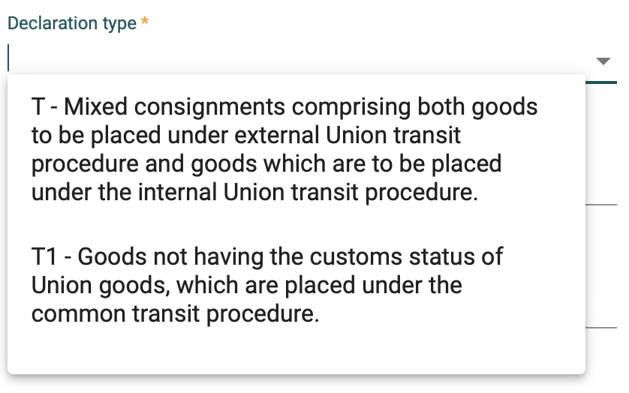

Figure 7 Short search list

Short search list data elements (fields) are populated with a limited number of values. They consist of the following parts:

1. The data field where the actual value of the data element is displayed/entered
2. The drop-down list where all available values for the specific element are displayed

Values from short search lists can be selected by:

1. Scrolling the drop-down list and selecting the desired value with a mouse right click
2. Entering the desired values in the data field. As the user types in the data field, the component searches and displays all the entries that match the entered value. The user can select any of the displayed values with a mouse right click. Alternatively, if only one value is displayed in the list it can be selected by hitting the “Enter”.

When a value is selected in the drop-down list, with any of the above methods, the selected value will automatically populate the data field.

### Long Search lists

Figure 8 Long search list

Long Search list data elements (fields) are populated with a wide number of values. Those elements are implemented with a use of a popup window that displays the available values in pages.

Long search list popup windows consist of the following parts:

1. The search field. The user can enter a value in the search field and then press the ‘magnify lens’ icon to filter the values that are displayed in the values grid.
2. The values grid, where all available values for the specific element are displayed. To facilitate the navigation between the available pages, the grid includes the grid footer component. See section ‘2.3.2 Grid Footer’.
3. The ‘Cancel’ button. When the button is pressed, no value is selected, the popup window closes and the value of the element that is associated with the Long search list remains unchanged.
4. The ‘Select’ button. The button is activated when the user selects a value from the values grid. When the button is pressed, the selected value from the value grid is transferred to the form element that is associated with the Long search list.

### Date Selector

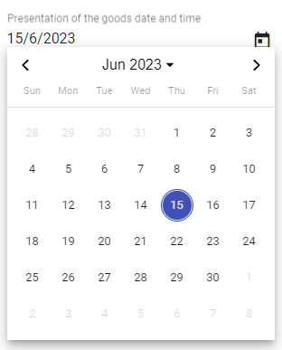The date selector component facilitates the filling of data elements that require a date value. It consists of the following parts:

1. Year selection short search list. The list allows the selection of a year and a month. Then the days of the week per month list is updated accordingly.
2. Previous **<** and Next **>** month navigation controls
3. The list of days of the week within the selected month and year

The date is selected by mouse right click on the desired date. Then the selected date value is transferred to the form element that is associated with the date selector component.

Figure 9 Date selector

### Document attachments



Figure 10 Document attachments

When the ‘paperclip’ icon is pressed, the operating system file selector window opens to facilitate the selection of a file from the file system of the user’s workstation.

## Interface Scaling (Adaptive Behaviour)

The interface is adaptive to the screen size and resolution. As the screen size is reduced (for example on a smaller monitor screen) the screen elements (Menu Items, Selected item sections) will automatically adjust to the screen size in three distinct steps:

### Full size display example

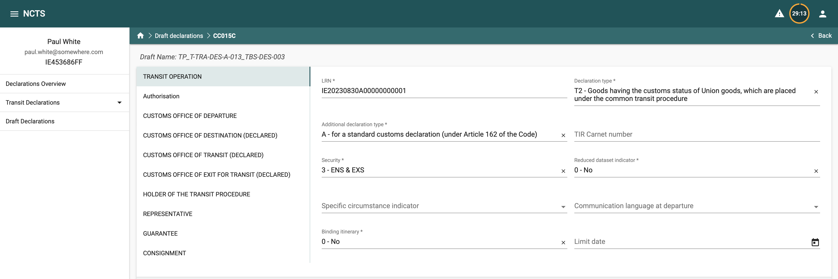The screen below shows a full size display example.

Figure 11 Full Size Screen example

### Next smaller screen size

In this next screen size, the left pane sections are collapsed:

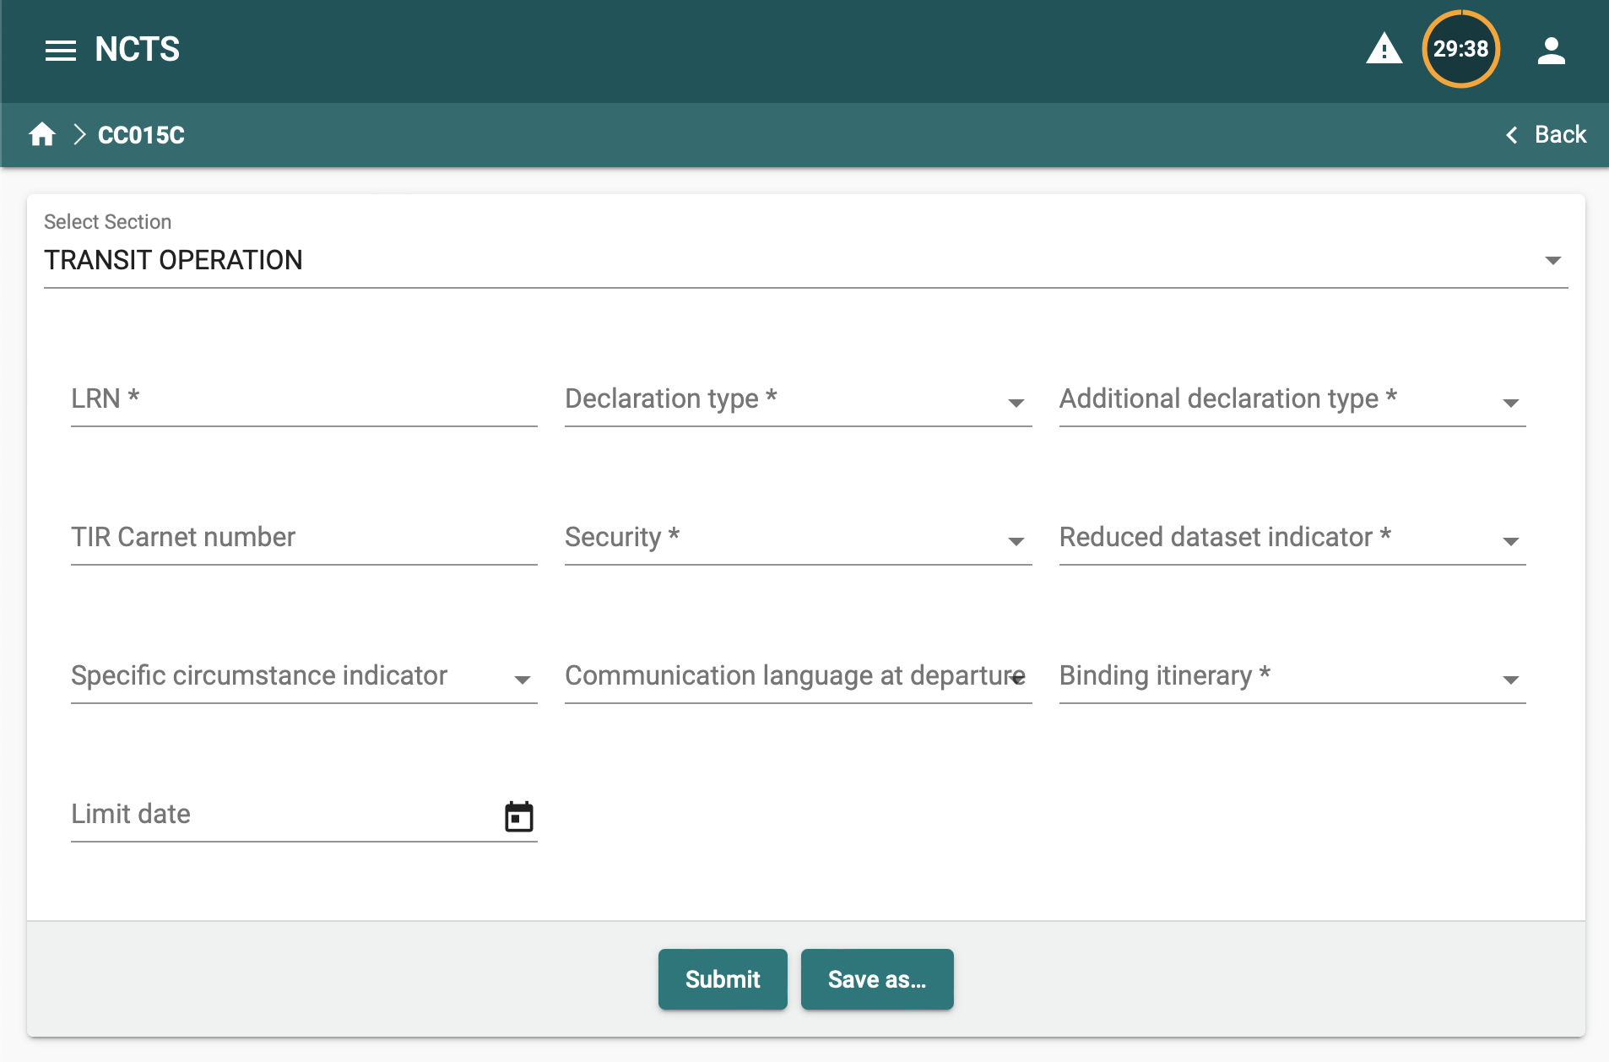

Figure 12 Intermediate Screen Size example

When clicking on the “Select Section” object, the section list appears:

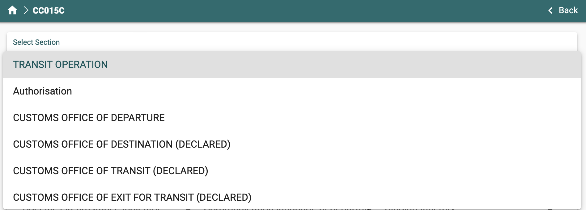

Figure 13 Select Section example

### Smallest screen size display

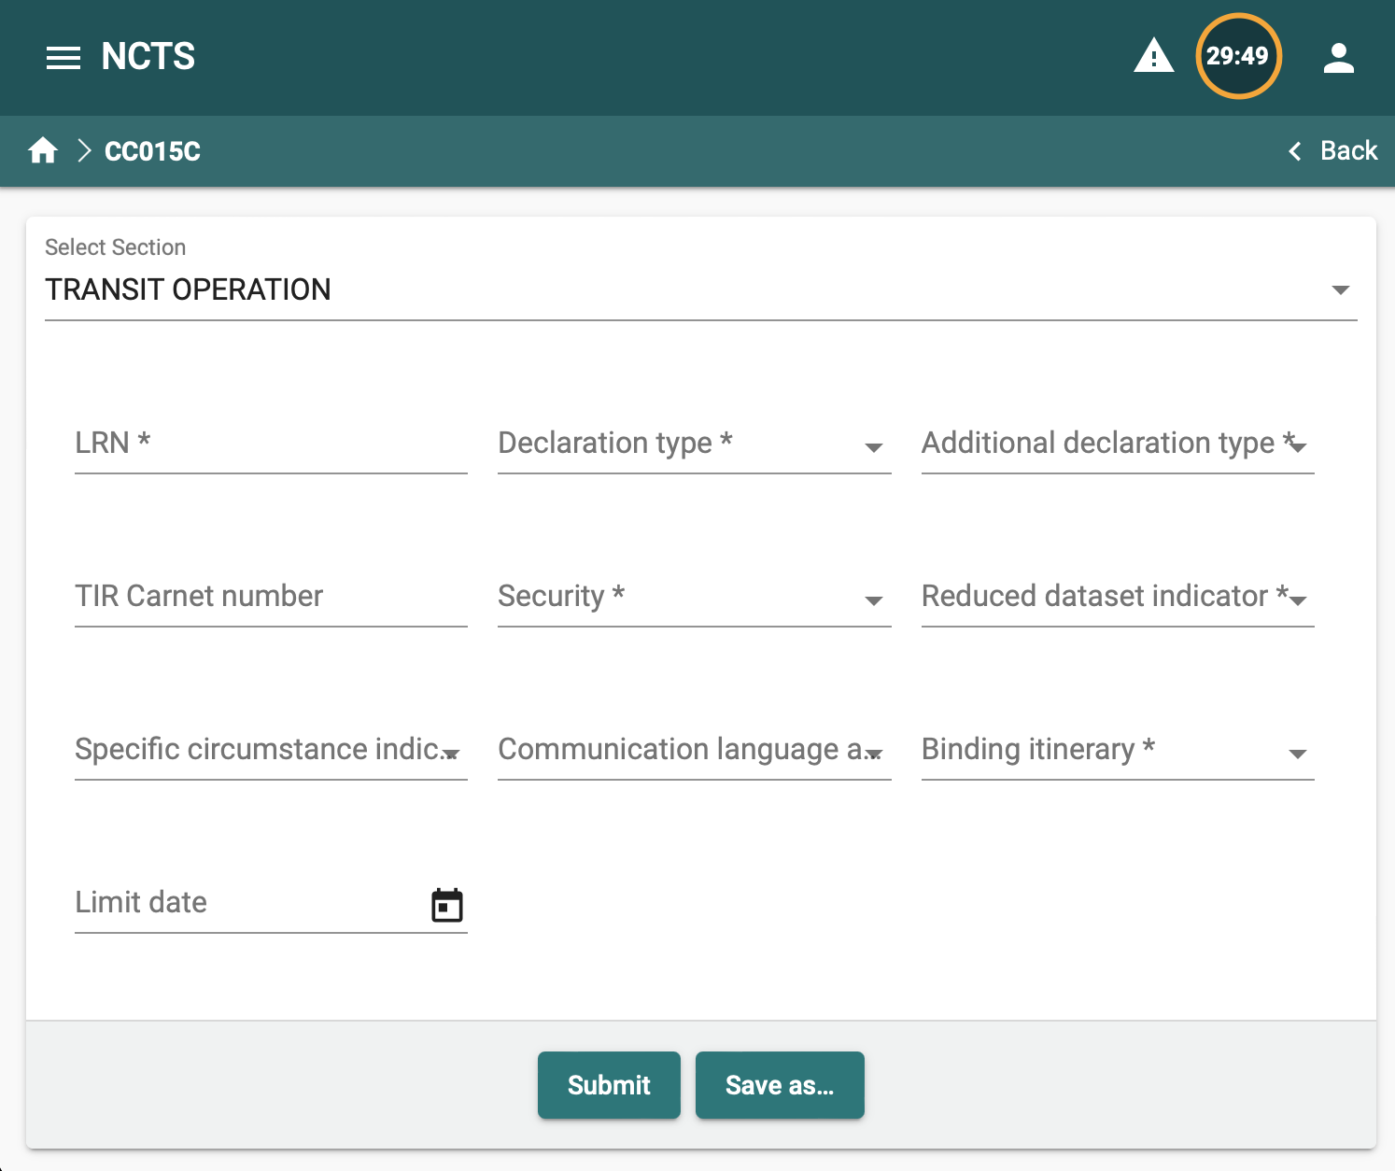

Figure 14 Smallest screen example

In this smallest display size, the AES menu can be displayed as an overlay by clicking on the object  as shown in the image below:

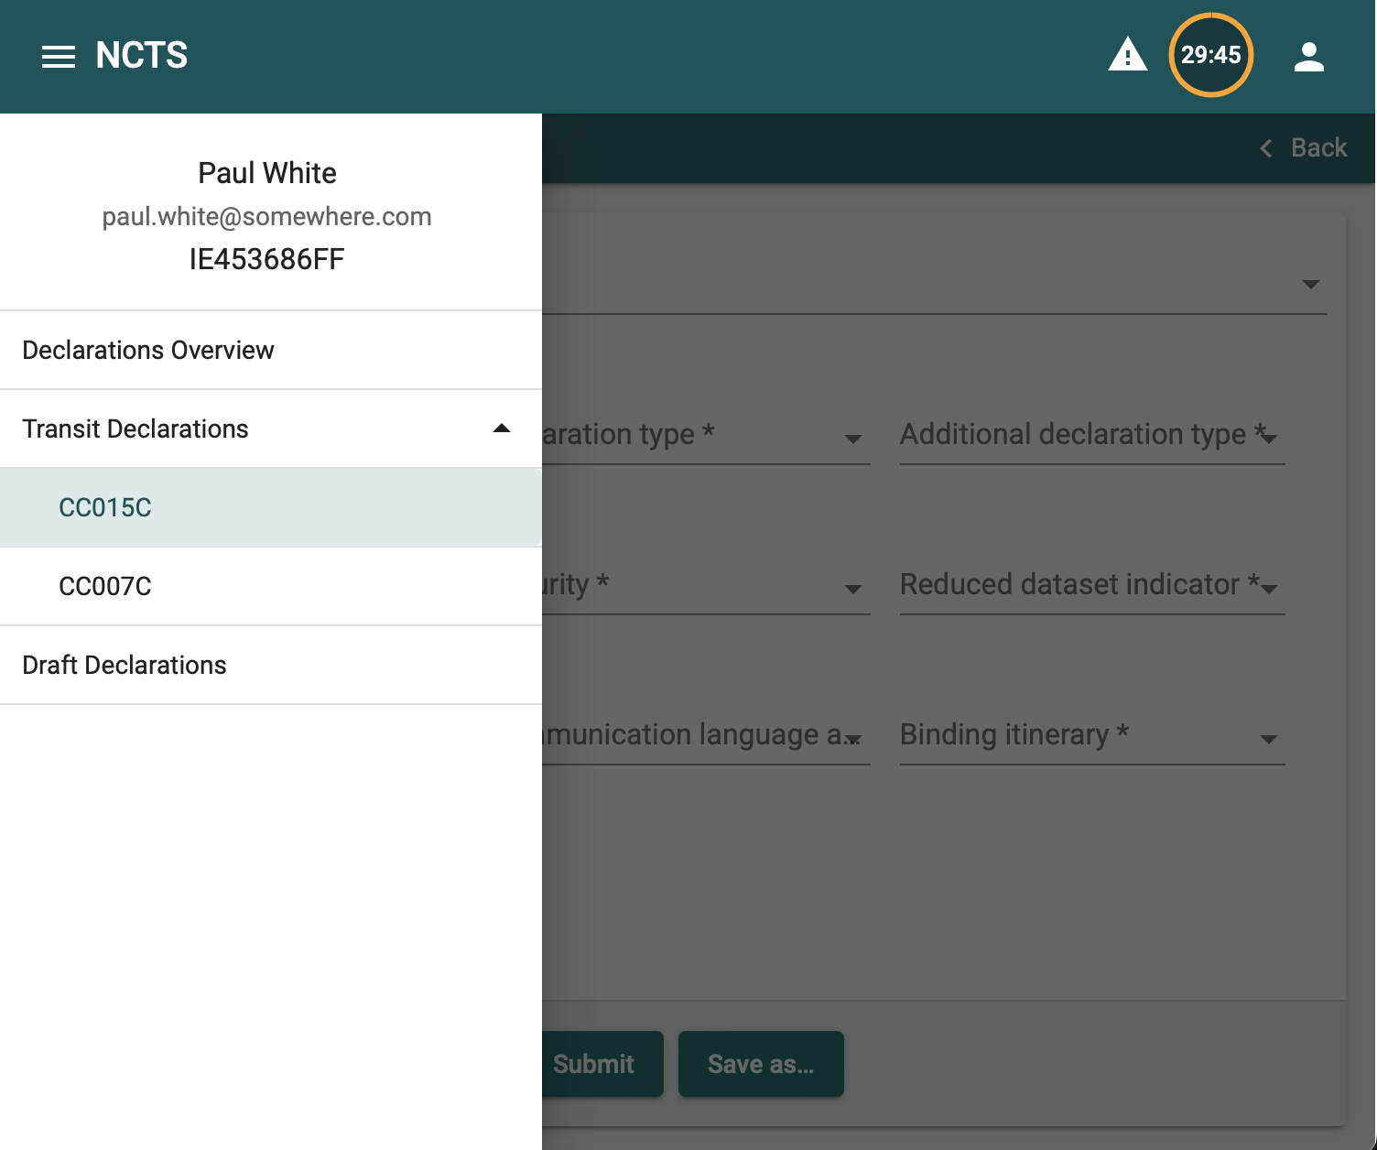

Figure 15 Smallest screen size show menu

# Basic Concepts and Terms

## Declaration

A Customs Declaration is a collection of data elements (dataset) that contains all required and optional fields according to the UCC (Union Customs Code) as published in the EUCDM 6.2 (European Union Customs Data Model).

A Declaration starts as an initial dataset message (such as IE015 for Transit declarations). In the processing of the declarations a number of related messages are created. For example, when a declaration has been successfully submitted and validated, it acquires the status ACCEPTED which, in turn, is communicated to the Holder of the Transit Procedure system (or visible in the portal) as message IE028. The declaration plus all related messages is referred to as a “movement” or “transaction” interchangeably. All messages related to a declaration, reference the declaration’s MRN (Movement Reference Number).

## Declaration Status

The declaration status denotes the processing stage of the declaration in the system. The status is a pivotal concept in declaration processing because it governs which actions are allowed on the declaration (such as amendment, invalidation, etc.)

For a description of all possible declaration statuses and the respective applicable actions, please see section *7 Appendix Α – Declaration Action Matrix*

There are also actions that can be performed at any declaration status. Those actions are:

1. View declaration/notification/message
2. Upload Attachments

# Main interface sections

The interface consists of the following main sections displayed in the left pane of the main (home) screen:

## Overview:

The overview section is split into two sub-sections:

### Declarations

The declarations section lists all declarations submitted by the logged-in user as shown in the following screen:

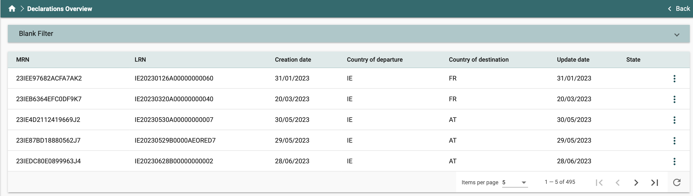

Figure 16 Declaration Overview grid example

#### Grid columns

The following columns are displayed in the Declarations grid:

| **Column name** | **Description** |
| --- | --- |
| MRN | The MRN of the entry |
| LRN | The LRN of the entry |
| Creation Date | The date the declaration was received by the system |
| Country of Departure | The Country of Departure for the Transit movement |
| Country of Destination | The Country of Destination for the Transit movement |
| Update date | The date the last message referencing the declaration MRN was registered in the system |
| State | Movement Status |

Table 1 Declaration Overview grid columns

#### Declarations available actions

The action selector in the Declarations grid will display the following options depending on the type of declaration and its status. For the complete list of actions per declaration status, see section *7 Appendix Α – Declaration Action Matrix*

##### View declaration screens

When selecting “View” from the action sub-menu, the “Declaration Details” data grid is displayed. This grid has three sections:

1. Header element. The Header element contains the following columns for the movement:
   1. MRN
   2. LRN
   3. Customs Office
   4. Creation date (Date the initial declaration message was received by the system)
   5. Updated date (Date of the latest message that references the movement MRN)



Figure 17 Customs Declaration detail header

1. Movement message history. This grid contains all messages that reference the movement’s MRN in reverse chronological order (newest to oldest). The following columns are displayed:
2. Creation date (Date the message was received by the system)
3. Event/Message type (The message code)
4. Message sender
5. Message recipient
6. Action selector for the entry (“View” is the only available action here)

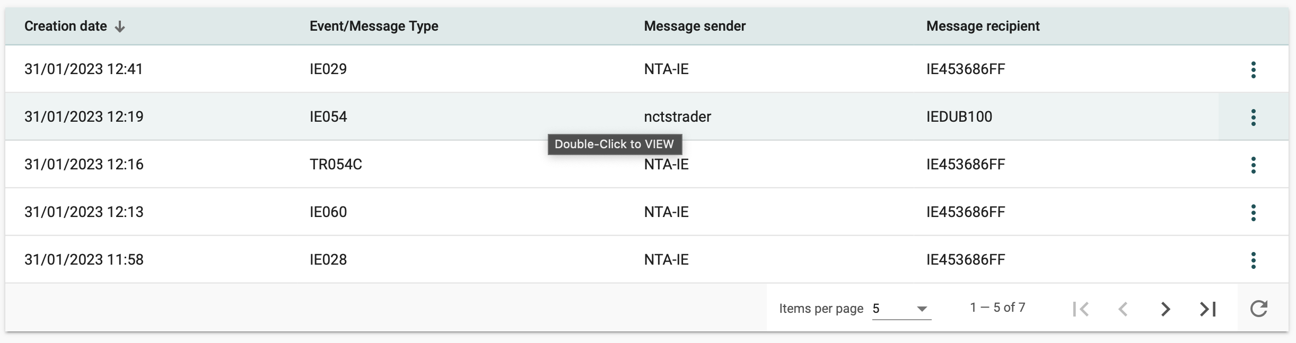

Figure 18 Movement messages grid

**View declaration message**. To view an individual entry, double-click the selected row, or click on the action selector and click on “View”. The following shows the “View” screen layout:

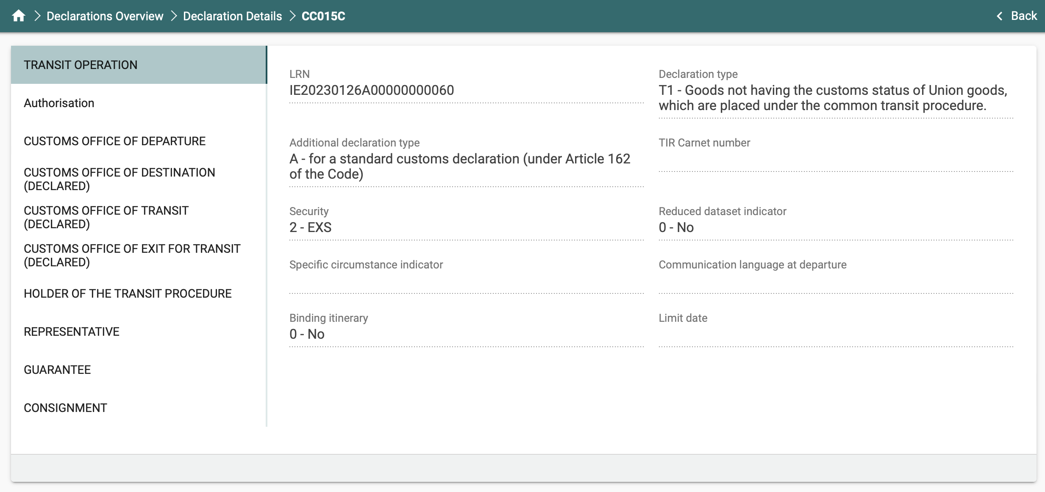

Figure 19 View Declaration Message screen example

**Note:** The list of available sections vary depending on the declaration message selected. Clicking on a specific section, the system displays the item’s sub-sections. The  and  symbols signify extendible / collapsible sections.

1. Supporting Document: This data grid contains any document upload entries for the movement. The following columns are displayed:
2. Filename
3. Description
4. Creation date
5. Uploaded by:
   * 1. Uploaded by a trader user. The username is displayed.
     2. Uploaded by Customs. “Customs” is displayed

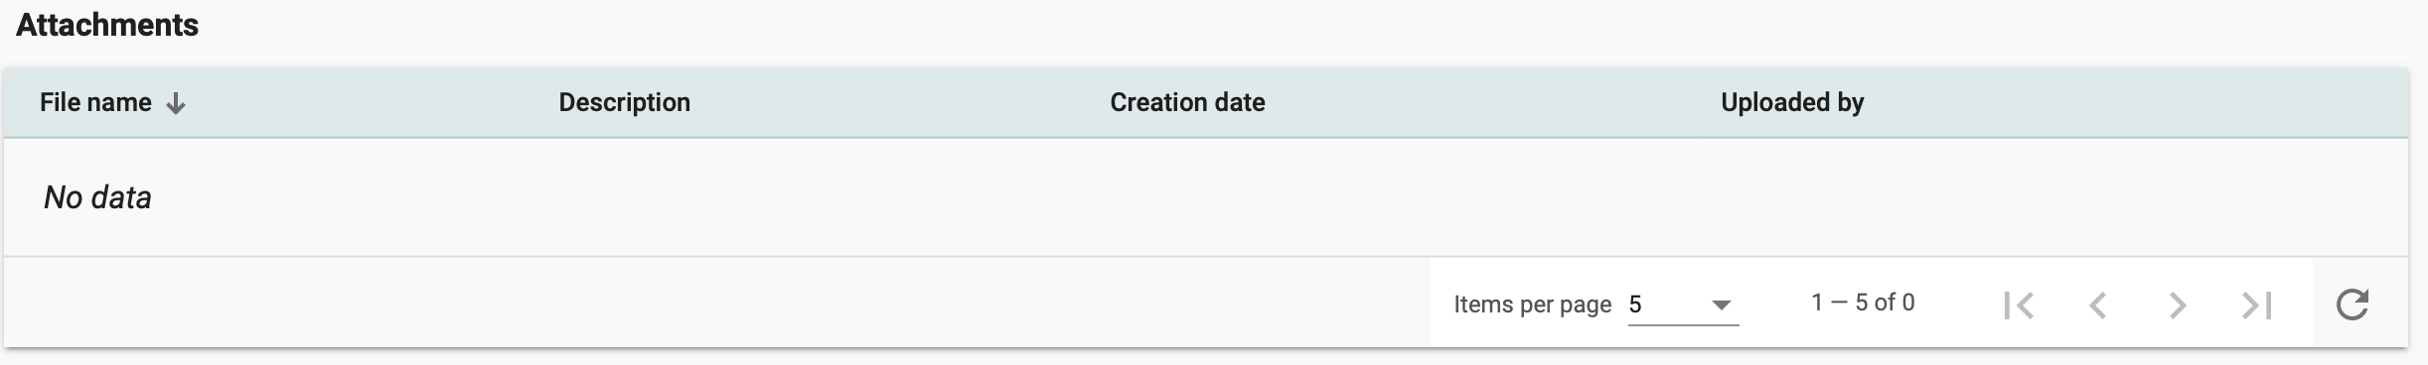

Figure 20 Supporting Document (Attachment) grid

## Transit Declarations

To start creating a declaration or notification, navigate to the respective section in the main menu (left pane).

1. 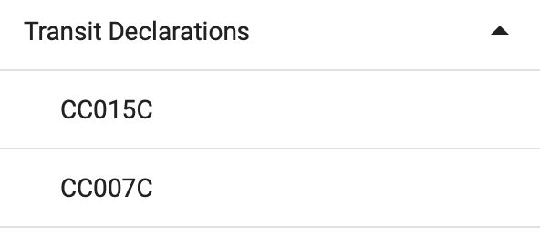CC015C: Transit Declaration
2. CC007C: Arrival Notification

Click on the desired declaration or notification to start creating the dataset from scratch.

### Draft declarations

At any time during the creation process, progress can be saved by clicking on the “Save as” button and providing a name for the draft declaration. This will create a draft copy of your dataset in the “Draft declarations” section.

“Draft” declarations can be retrieved by navigating to the “Draft Declarations” section. To resume work on a draft dataset, select “Edit” from the available actions on the draft entry.

A “Delete” action is also available to delete a saved draft declaration.

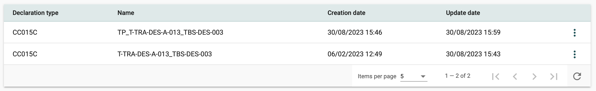

Figure 21 Draft declarations grid

### Required vs. Validated data elements

All declaration datasets contain required fields (indicated by an asterisk in the respective field description).

A number of declaration data elements are also validated upon declaration submission.

The behaviour of the system is different in these two cases:

1. If any required field (i.e. fields that require a value and cannot be left blank) is not completed, the submit button will not result in declaration submission and validation. However, the section(s) descriptor(s) where the required fields are left blank will be displayed in red and the Mandatory value indication will be displayed.

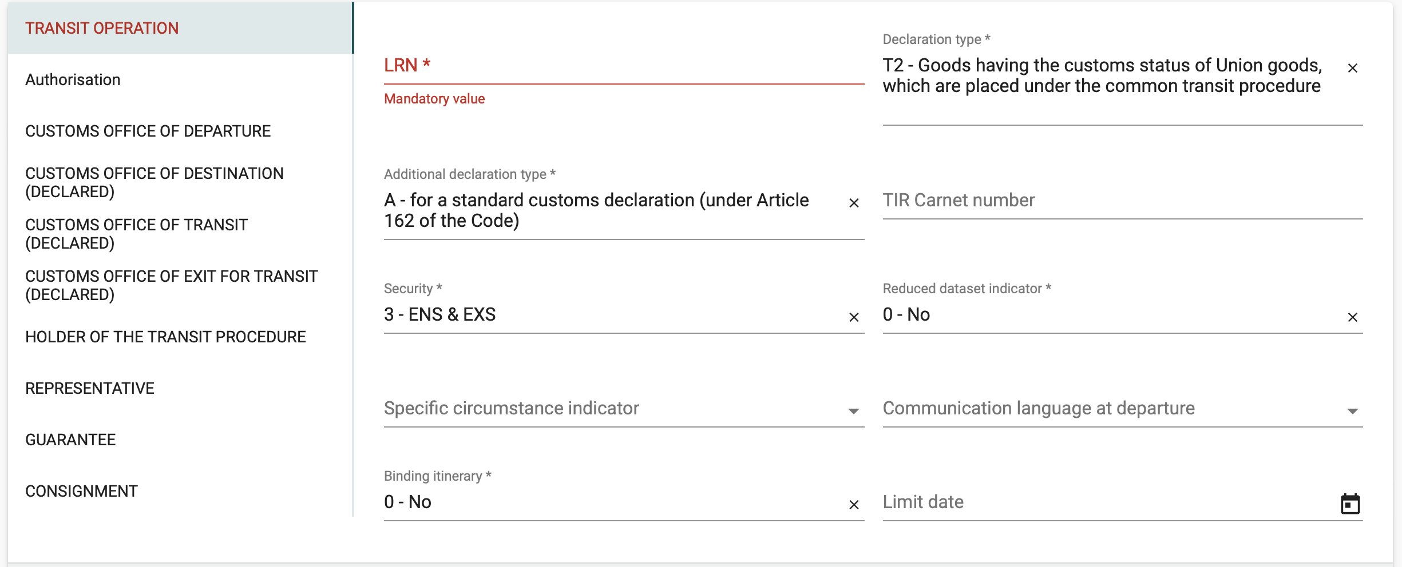

Figure 22 Required fields missing

1. If all required fields contain values, the declaration will be submitted to NCTS and validation will be performed. If any validation rules are violated, in addition to the visual indication above, the system will display a pop-up box with the list of all validation errors.

The following screen shows an example of a validation error list:

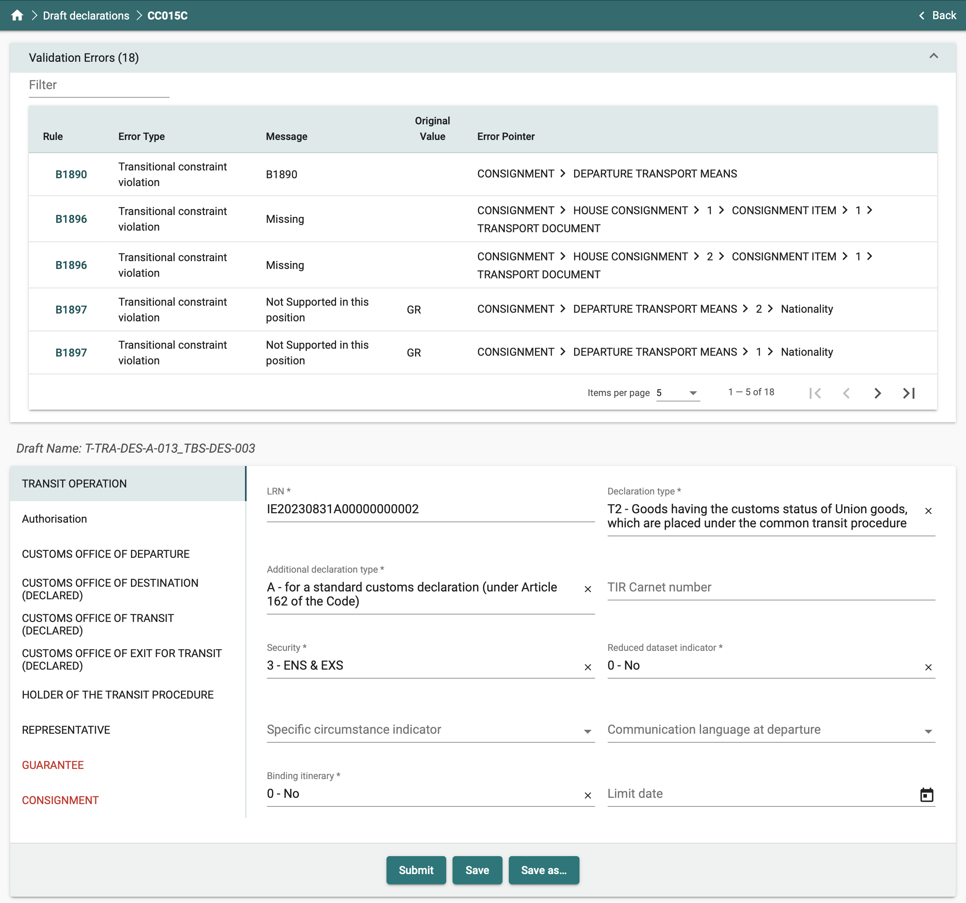

Figure 23 Validation errors screen example

### Validation errors

All validation errors contain the following information:

* Rule: Violated business rule (Bxxxx or Rxxxx) or condition (Cxxxx) code ID[1]
* Message: Error description
* Original Value: The value contained in the data element
* Error Pointer: Indication on the location (field) of the error in the declaration

# Creating and Submitting Declarations

For the creation and the lodgment of NCTS declarations the reader must consult the following documents:

* 1. NCTS Message Exchange document. The document describes the information (messages) that a Holder of the Transit procedure will be exchanging with NCTS and the respective state transitions
  2. NCTS Message Structures document. The document contains the logical structure of all messages exchanged between the Holder of the Transit procedure and NCTS.
  3. NCTS Codelists document. The document contains the data for the codelists that are referred from within the NCTS Message Structures document
  4. NCTS Business Rules and Conditions document. The document contains all business rules and conditions referred from within the NCTS Message Structures document and are applied during message validation

# Declaration Specific Guidance Information

The following sections explain the steps required to create and submit a declaration. More detailed description of the available exchanges with NCTS are described in the NCTS Message Exchanges document.

There are two possible channels for a declaration to be submitted. The provided forms and B2B. NCTS is monitoring the initial messages (i.e. IE015, IE007) and registers the channel from which that declaration is received. NCTS will utilize that channel for all message communication with the Holder of the Transit Procedure or the Trader at Destination. All the exchanged messages via B2B will also be available on the portal to view.

The following processes are available for both channels (portal and B2B). Detailed information on the messages, their structure, the logical requirements and the respective business flows can be found in the Trader specification documents. (see section *5 Creating and Submitting Declarations*).

## Creating a specific declaration / notification

To start creating a declaration or notification the Holder of the Transit Procedure or the Trader at Destination can utilize the provided forms in the Trader portal or by lodging the respective messages via B2B.

At any time during the declaration creation process a draft version can be saved. This facility can function both as a method for storing declaration “templates” that can be modified and re-used, and as a way to store working copies of declarations where work can be resumed at a later time.

## Declaration Amendment (Holder of the Transit Procedure initiated)

Depending on the movement status, a declaration can be amended by the Holder of the Transit Procedure. The amendment process is started by selecting “Amendment” from the action selector.

After selecting the “Amendment” action, the current state of the declaration is loaded in a declaration screen, which allows the user to edit the declaration data and submit the amendment as an IE013 message.

The amended declaration will go through validation and if accepted, an IE004 (Amendment Acceptance) message will be generated by NCTS.

If the amendment fails validation, an IE056 (Rejection From Office Of Departure) message will be generated by the system.

If the state of the Transit movement does not allow amendments, then the “Amendment” option will not be available in the declaration action selector.

## Declaration Amendment (Customs Officer Amendment request)

During customs controls (Physical or Documentary), the case Customs Officer may request a particular amendment to be submitted for a declaration under control.

In this case, the system generates and sends message TR062 to the Holder of the Transit Procedure. An amendment is then allowed to be submitted even though the declaration is under control.

## Declaration Invalidation (Holder of the Transit Procedure initiated)

Depending on the movement status, a declaration can be invalidated by the Holder of the Transit Procedure. The invalidation process is started by selecting “Invalidation” from the action selector. If the “Invalidation” option is not available in the declaration action selector, invalidation is not allowed (e.g. Movement is under control).

After selecting the “Invalidation” action, a form is displayed which requires the Holder of the Transit Procedure to enter the reason for the invalidation request and submit the invalidation as an IE014 ( Declaration Invalidation Request) message.

The invalidation request will go through validation and if accepted, an IE009 (Invalidation Decision) message will be sent by NCTS with a positive decision.

If the amendment fails validation, an IE056 (Rejection From Office Of Departure) message will be sent by NCTS with a negative decision.

## Declaration Invalidation (Customs Officer Invalidation request)

During customs controls (Physical or Documentary), the case Customs Officer may request the invalidation of a declaration under control.

In this case, the system generates and sends message TR064 to the Holder of the Transit Procedure. An invalidation is then allowed to be submitted even though the declaration is under control.

The invalidation request will go through validation and if accepted, IE009 (Invalidation Decision) message will be sent by NCTS with a positive decision.

If the amendment fails validation, an IE056 (Rejection From Office Of Departure) (Invalidation Request Decision) message will be sent by NCTS with a negative decision.

## Attaching a Document to a Declaration

To attach a document in a movement, select “Upload Attachments” from the action selector of the movement. NCTS will display the Upload attachments form. Select the Attachments section and NCTS will display the following screen:

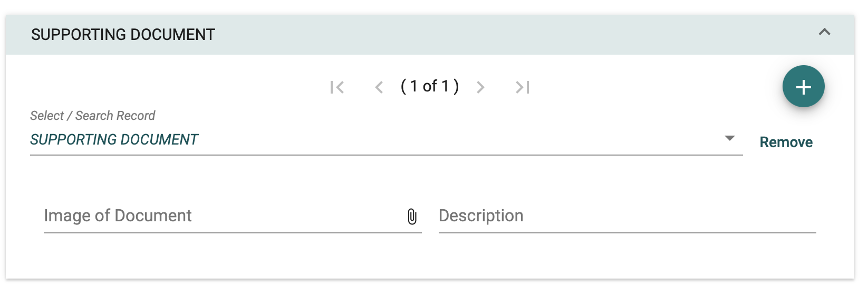

Figure 24 Uploading an Attachment

Clicking on the paper clip symbol, a standard browser screen is displayed for selecting a file to attach as in the following example (Windows 10 client):

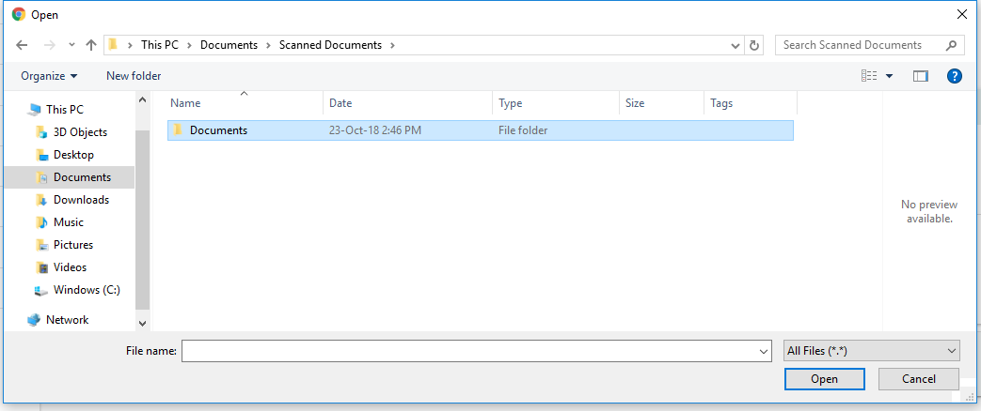

Figure 25 File Browser example

Any attachment can be uploaded to the system as supporting documentation except for the following file types (contents and file extensions):

|  |  |  |  |  |  |  |  |
| --- | --- | --- | --- | --- | --- | --- | --- |
| .ade | .adp | .apk | .appx | .appxbundle | .bat | .cab | .chm |
| .cmd | .com | .cpl | .dll | .dmg | .exe | .hta | .ins |
| .isp | .iso | .jar | .js | .jse | .lib | .lnk | .mde |
| .msc | .msi | .msix | .msixbundle | .msp | .mst | .nsh | .pif |
| .ps1 | .scr | .sct | .shb | .sys | .vb | .vbe | .vbs |
| .vxd | .wsc | .wsf | .wsh |  |  |  |  |

Table 2 Invalid Attachment File Types

Examples of common allowed attachment file types include (but are not limited to):

|  |  |  |  |  |  |  |
| --- | --- | --- | --- | --- | --- | --- |
| pdf | gif | png | jpg | jpeg | zip | 7z |

Table 3 Common Supported Attachment File Types

# Appendix Α – Declaration Action Matrix

The following table lists possible available actions that can be performed on a movement message in possible declaration statuses. Conditions apply in all cases that determine which actions are available.

The following actions are excluded from the table below:

* View
* Save as Draft
* Add Attachments
* View Declaration

| **Status** | **Actions Available** |
| --- | --- |
| ACCEPTED | DECLARATION_AMENDMENT  DECLARATION_INVALIDATION_REQUEST |
| BUSINESS_CASE | DECLARATION_AMENDMENT  DECLARATION_INVALIDATION_REQUEST |
| ENQUIRY_RECOMMENDED | UPLOAD_ATTACHMENTS  UPLOAD_ALTERNATIVE_PROOF  SENDCC140CRESPONSE |
| GUARANTEE_REGISTERED | DECLARATION_AMENDMENT  DECLARATION_INVALIDATION_REQUEST |
| GUARANTEE_UNDER_AMENDMENT | DECLARATION_AMENDMENT  DECLARATION_INVALIDATION_REQUEST |
| MOVEMENT_RELEASED | UPLOAD_ATTACHMENTS  UPLOAD_ALTERNATIVE_PROOF  SENDCC140CRESPONSE |
| PRELODGED | UPLOAD_ATTACHMENTS  PRELODGED_PRESENTATION_NOTIFICATION  DECLARATION_AMENDMENT  DECLARATION_INVALIDATION_REQUEST  PRELODGED_PRESENTATION_NOTIFICATION |
| SUBMITTED | UPLOAD_ATTACHMENTS  DECLARATION_INVALIDATION_REQUEST |
| UNDER_CONTROL | UPLOAD_ATTACHMENTS  SUBMIT_DOCUMENT_DATA |
| UNDER_ENQUIRY_PROCEDURE | UPLOAD_ATTACHMENTS  UPLOAD_ALTERNATIVE_PROOF  SENDCC140CRESPONSE |
| UNDER_RELEASE_REQUEST | UPLOAD_ATTACHMENTS  RELEASE_REQUEST |
| UNLOADING | UPLOAD_ATTACHMENTS  UNLOADING_REMARKS |

Table 4 Movement state Action Matrix

**-END OF DOCUMENT -**

1. For the complete list of Business Rules, please consult the “NCTS-Business-Rules-and-Conditions” companion document